*FOUND CHILD / LOST CHILD*

Missing child is a mobile application. It is used for finding your child in case of missing or lost. In this application basically, there are two options after the Sign-up/Sign-in in the application.

* **LOST CHILD**
* **FOUND CHILD**

**LOST CHILD:**

In the lost child, we insert necessary information regarding the child and upload a picture of the child. After completing the upper process, we will publish it. Now the missing child will be displayed on the post screen The users can react to the post and comment on the post and also share it on other social platforms like Facebook stories, What’s App Statuses, etc.

**FOUNT CHILD:**

In the found child option if the user finds any lost child, he uploads the picture of that child and uploads it. After done with this process user’s current location will be fetched and the application will check the picture of the child if any match is found the notification will be send to that specific user who has posted a missing child post and a link will be created between them. In case of a match is unfound so there will be two options displayed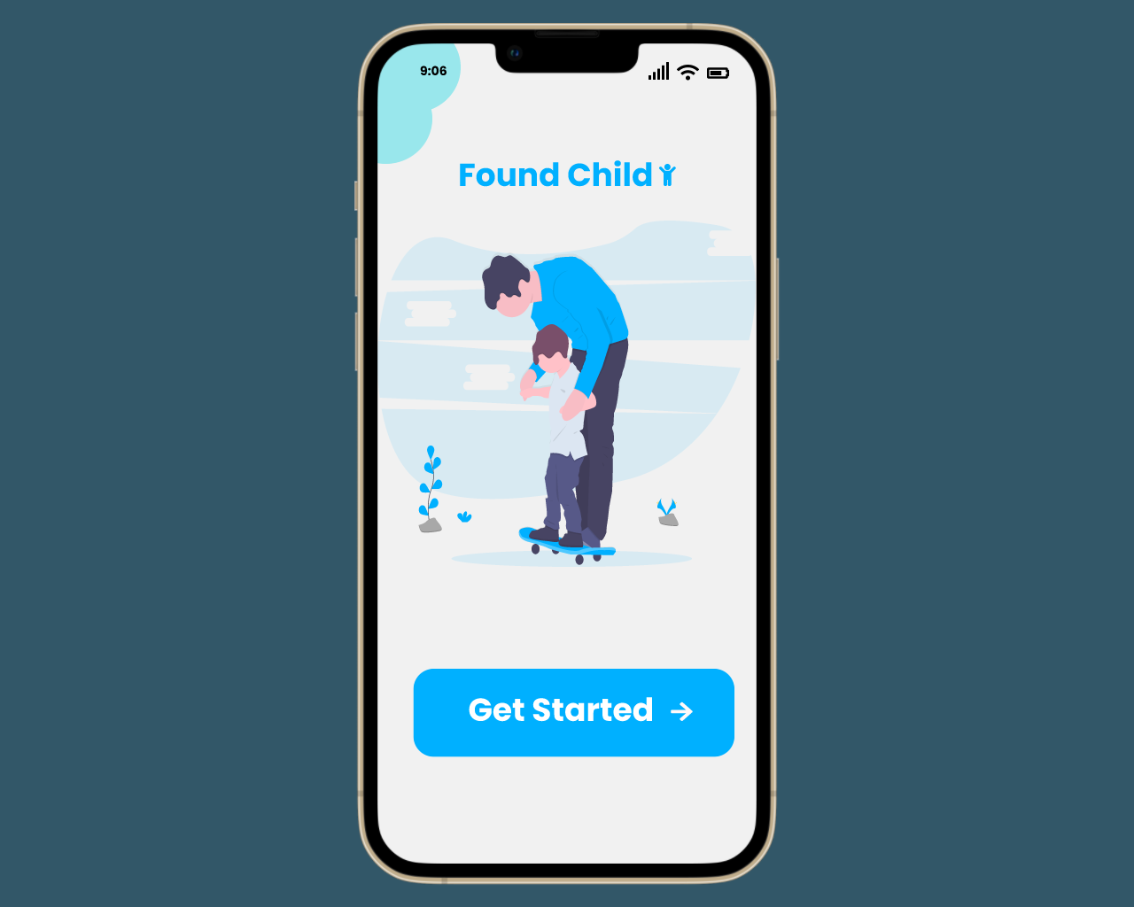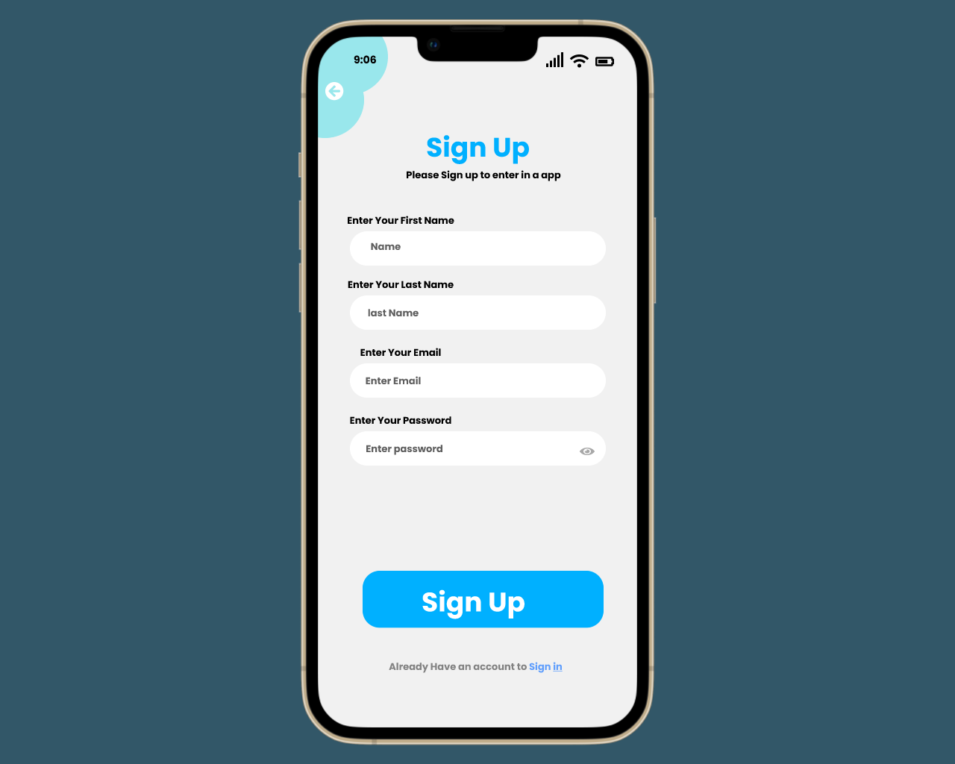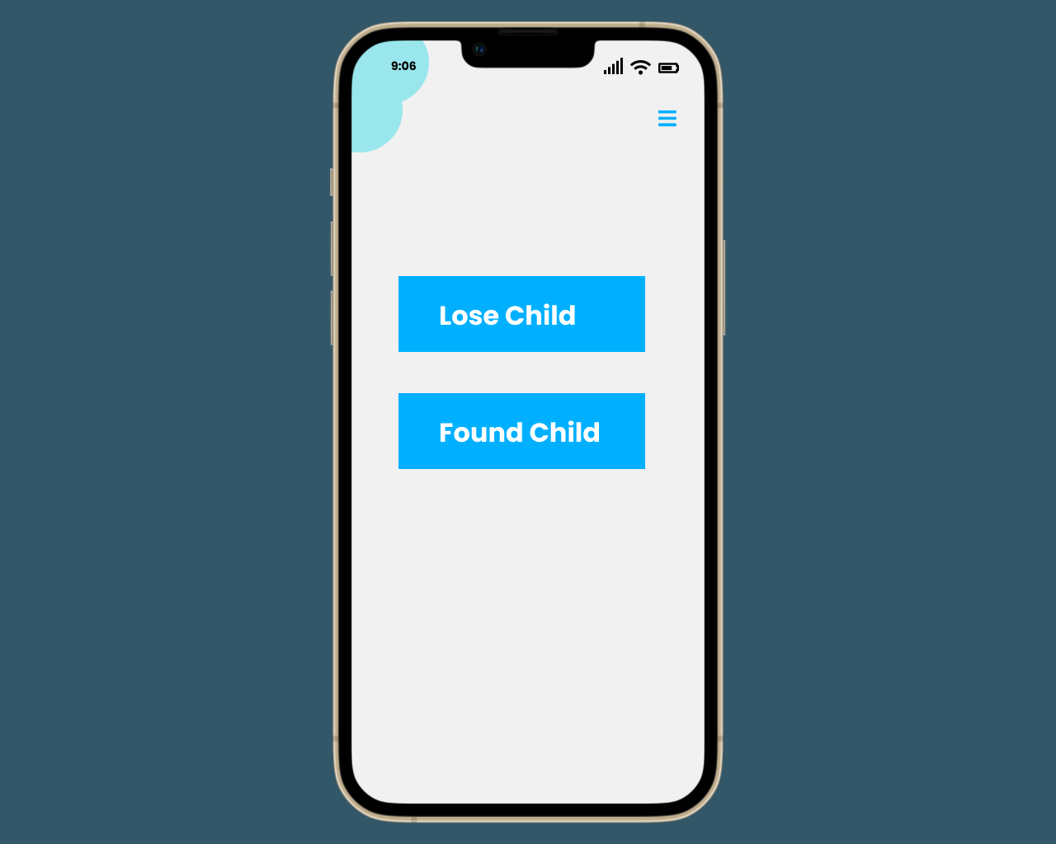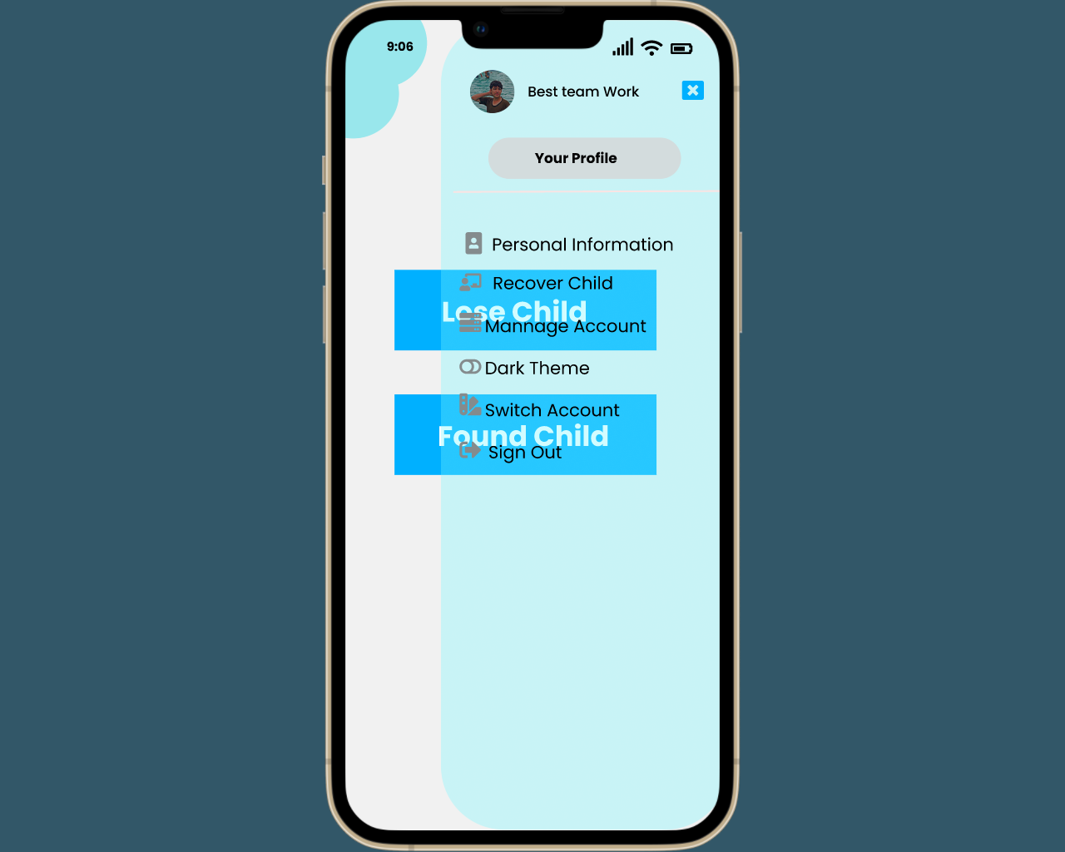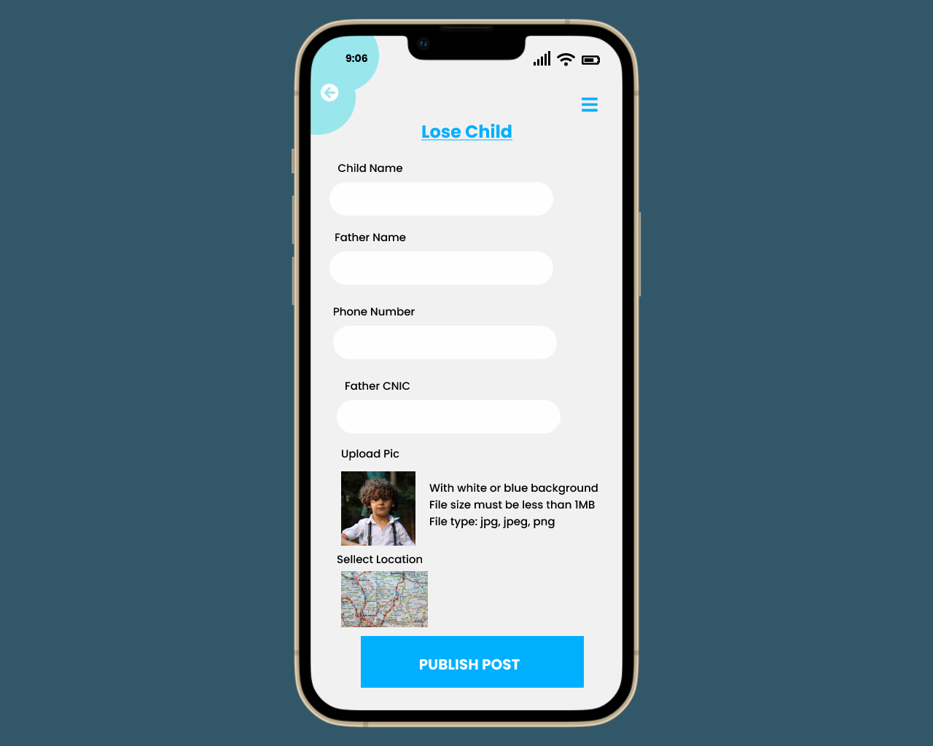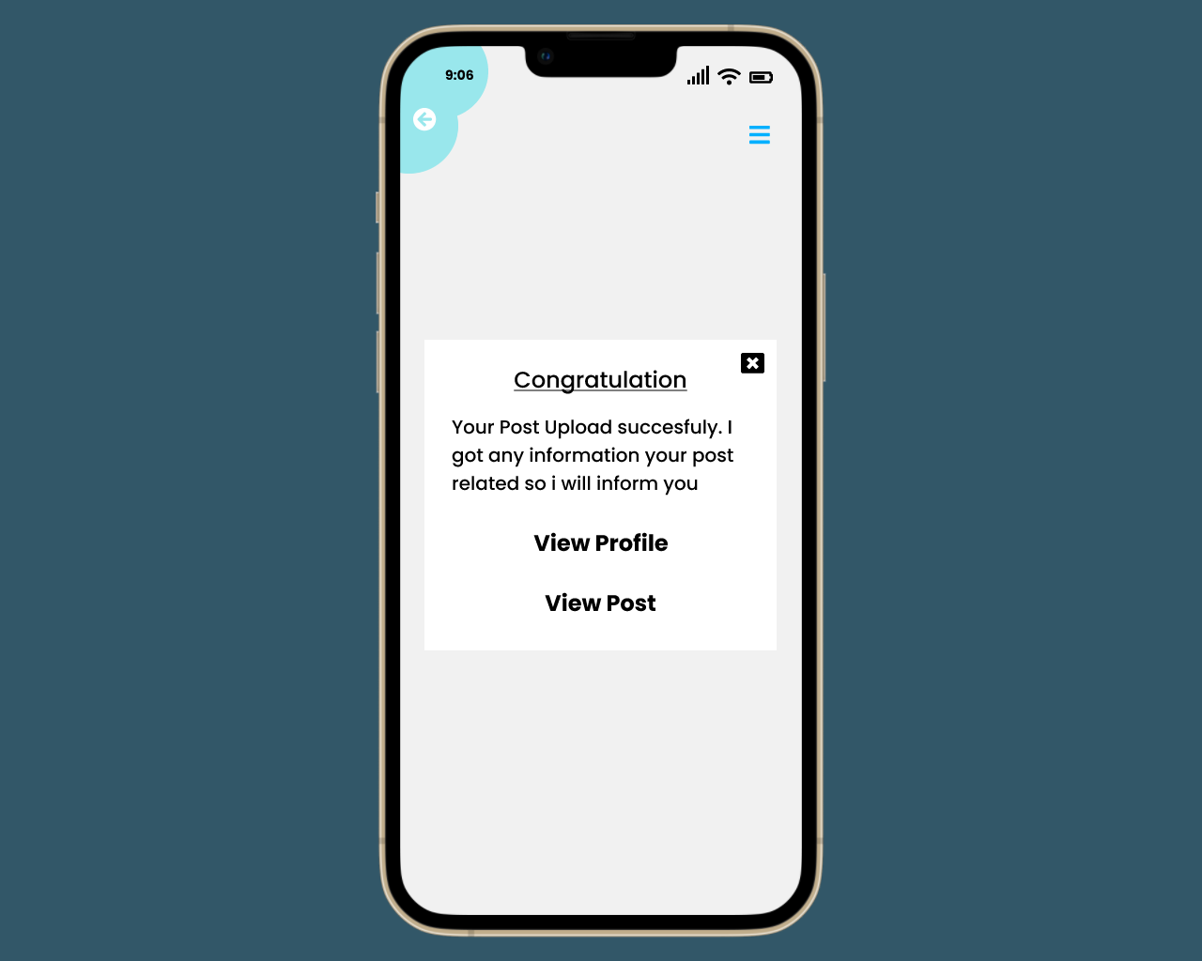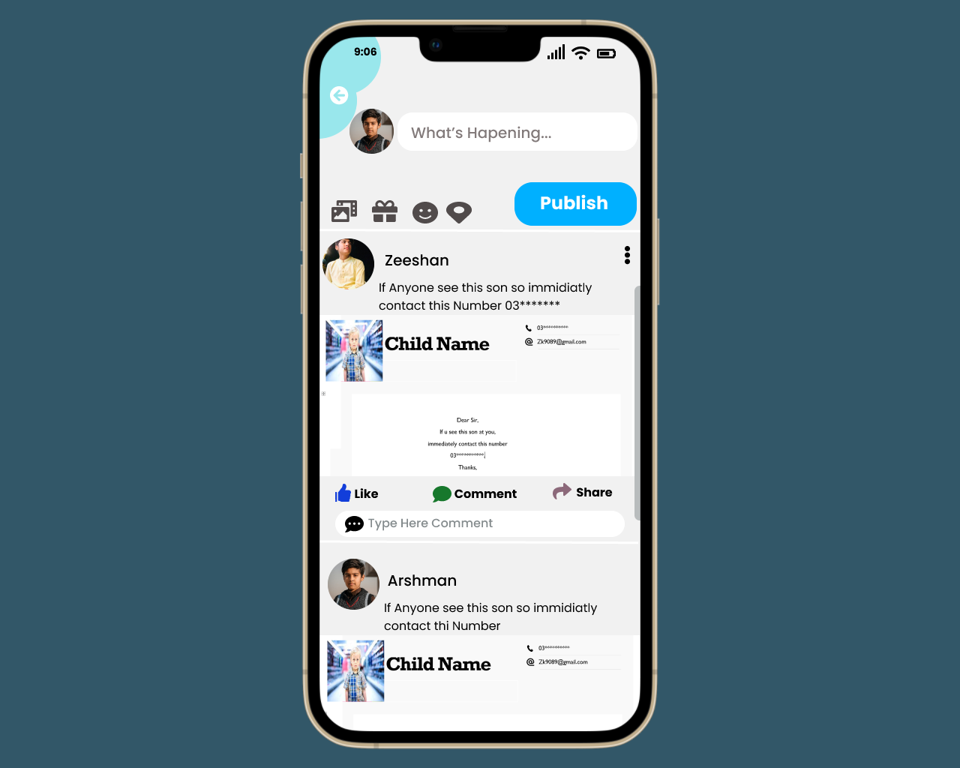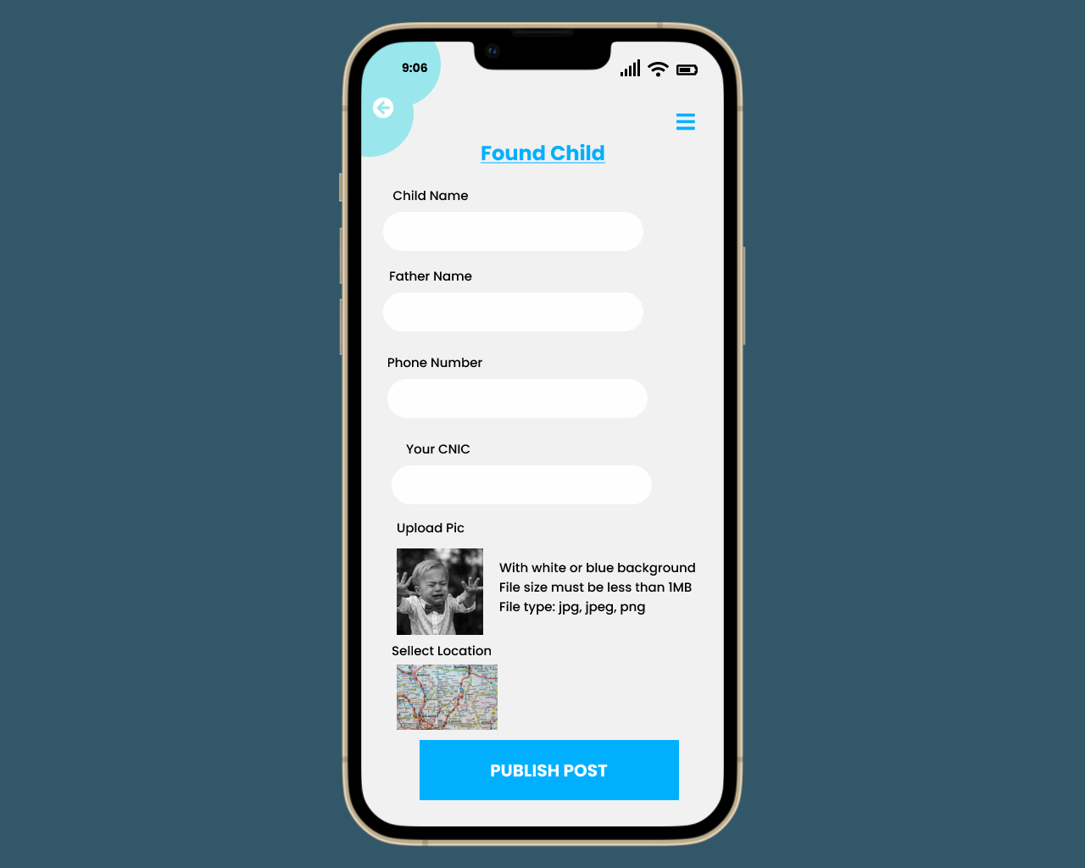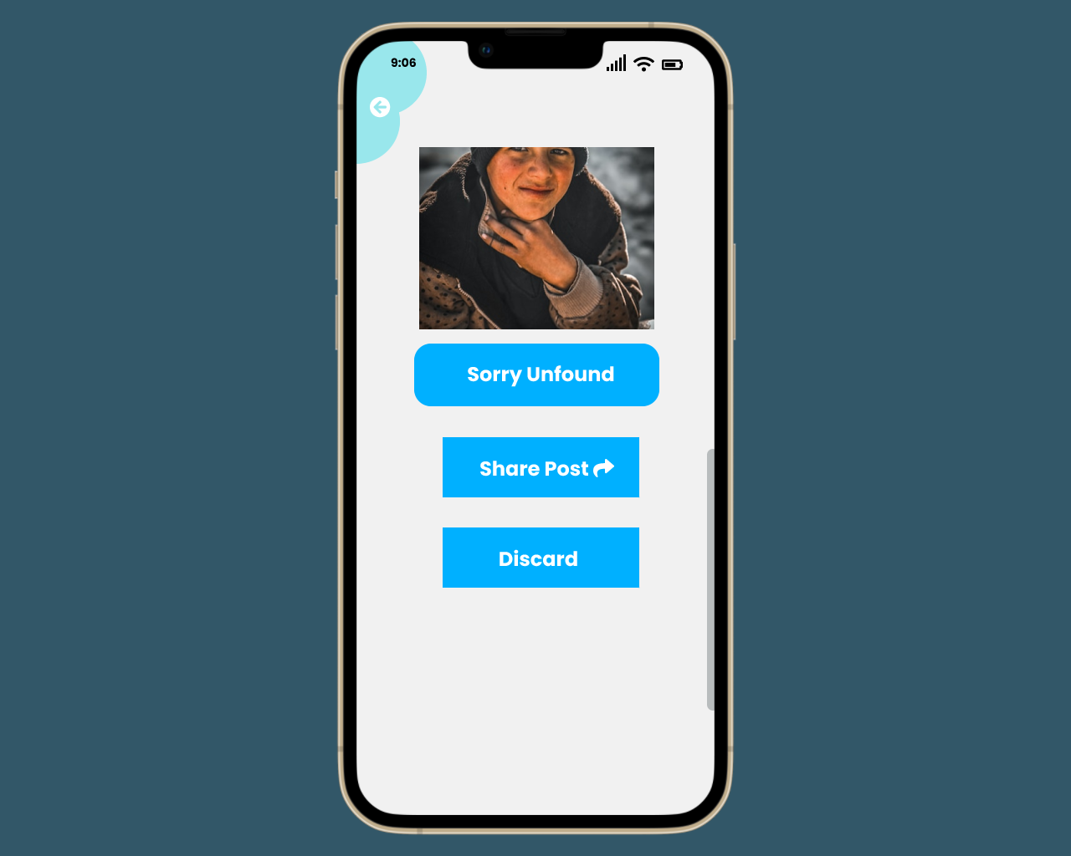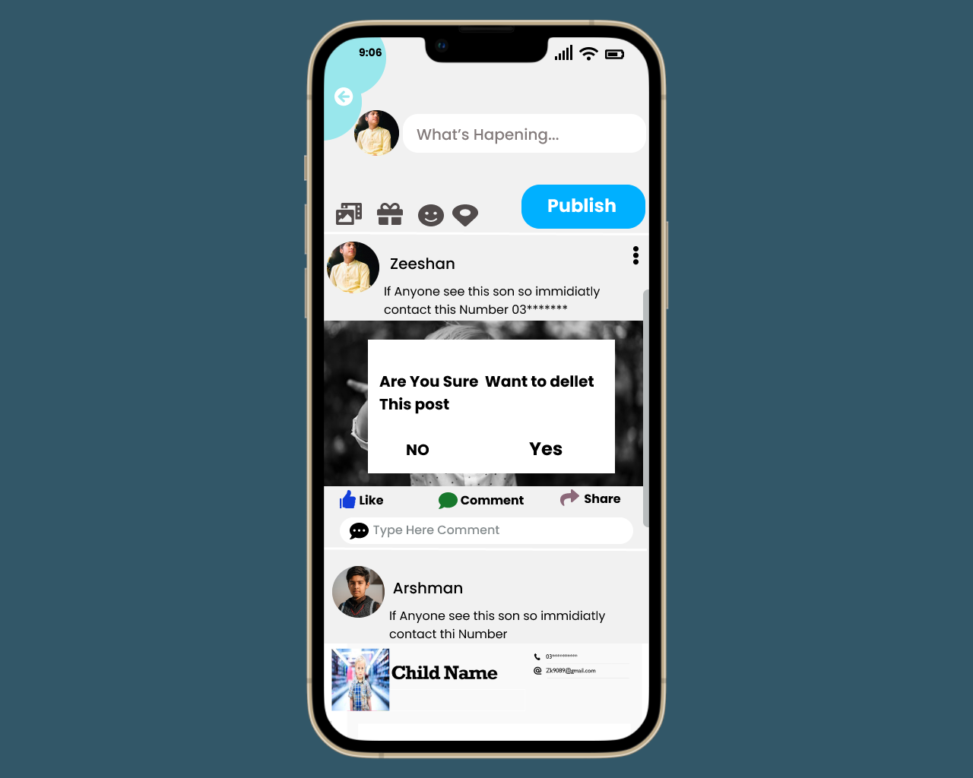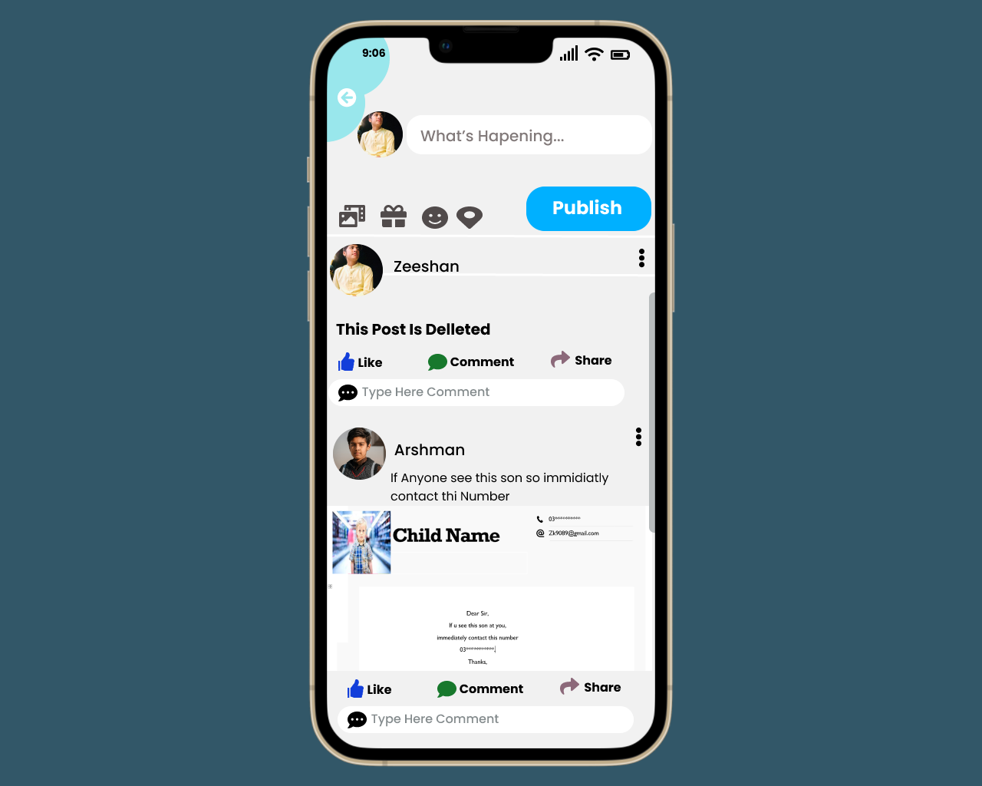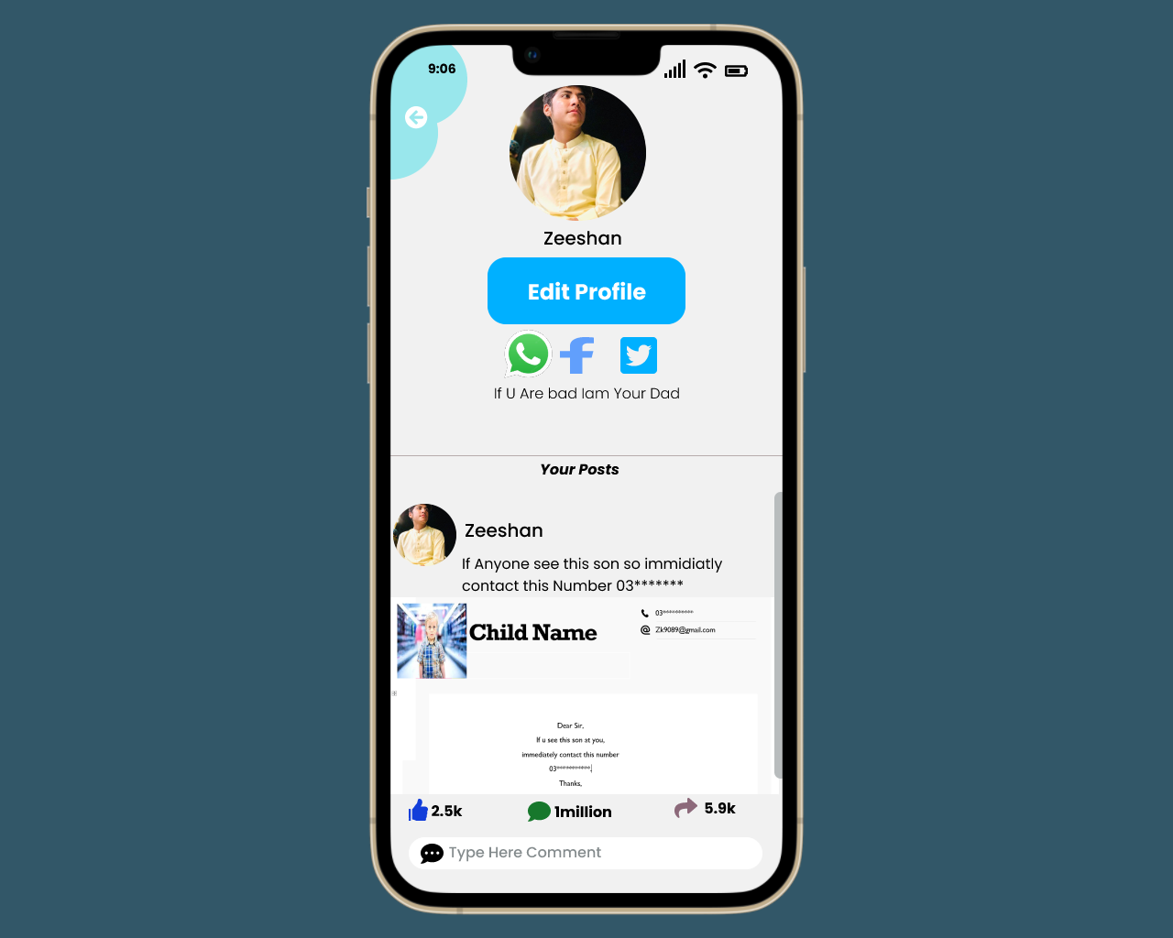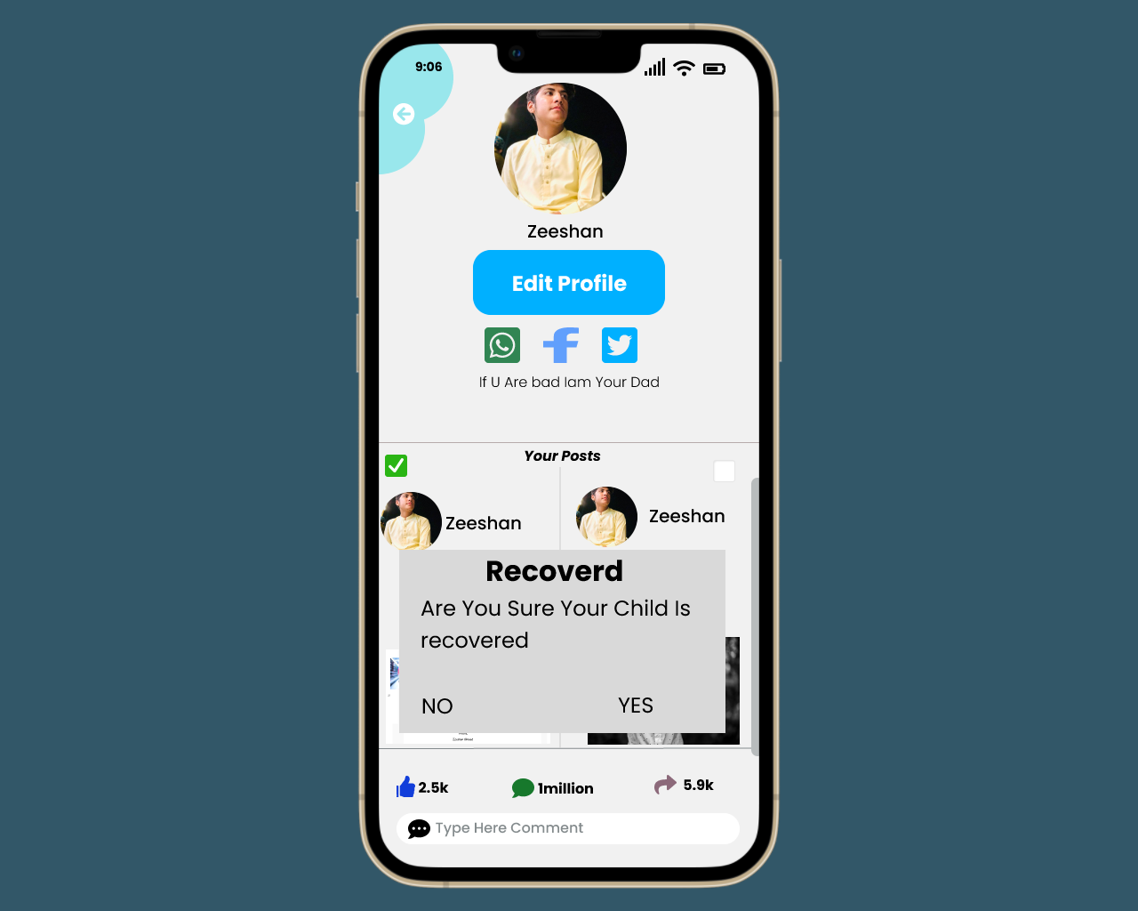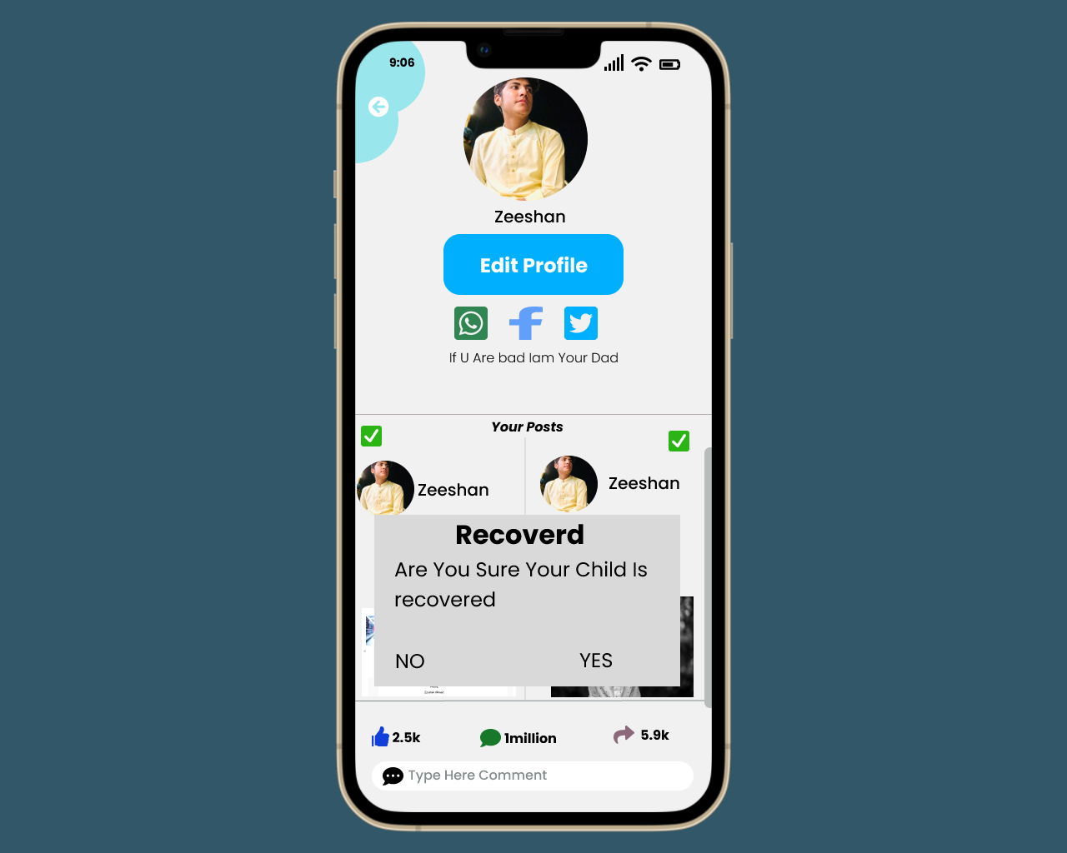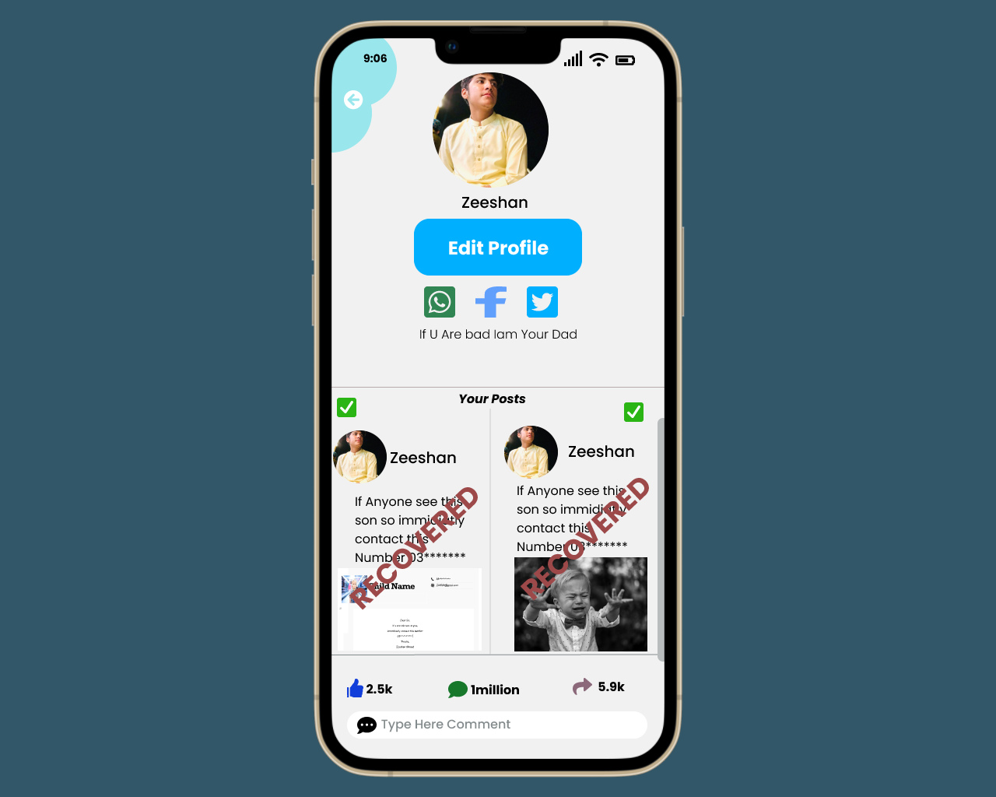

* **Share Post**
* **Discard**

On clicking the share post option, a missing child found post will be displayed on the posts screen. The user can also share it on social platforms. On clicking discard, the post will be deleted.

If the child is found the user has posted the missing child post will update his post set its status as child found. In Case of any fraud, there is also a Report option in the Application.